|  |
| --- |
| Robert van der Spoel |
| IT Graad 10 PAT – Fase 1 |
| Circuit Central |
| You may add an image / your own logo (not required) |

Table of Contents

**Define the task** 2

Topic: 2

Purpose of program: 2

Possible solution: 2

Scope: 2

**User Stories** 2

**Acceptance Test – List FOUR Functions** 2

**Data Dictionary** 2

User defined function 2

**Navigation** 3

**GUI Design** 3

Tab Sheet 1 (User 1): 3

INPUT: 3

OUTPUT: 3

Tab Sheet 2 (User 2): 3

INPUT: 3

OUTPUT: 3

**IPO – Software Design Tool** 4

INPUT VALIDATION: 4

PROCESSING: 4

# **Define the task**

## Topic: Computer Part Store. The store sell’s PC parts such as GPU’s, CPU’s and peripherals.

## Purpose of program: The company is new and doesn't have a wide range of customers. It is limited to in store purchases and doesn’t have a website. This problem limits the buyers to only the local residents. The owner doesn’t have a way to manage his customers.

## Possible solution: My program will enables the customer to order products online that will allow them to ask for delivery or in store pickup. This will allow for a wider range of customers as people from other areas can also access the store .On the admin tab

## sheet the admin will be able to control the program and manage his customer accounts. 3 Tab sheets have been dedicated to selling a product to the customer. A tab sheet has been made to allow the customer to checkout.

## Scope: My program will not be able to add new products, remove old products or change the prices of products. The product range is also limited to 12 items. It is also limited on the FPS calculator as it only supports a small range of options.

# 

# **User Stories**

User 1: Admin

| **WHO** | **WHAT** | **WHY** |
| --- | --- | --- |
| Admin | Change the theme of the program to a different colour | Configure the program to look the best and fit the customers. |
| Admin | See the accounts of the users | To help customers recover their Username or Password. |
| Admin | Change the icon of the program | To make the program more likeable and interesting. To keep it from feeling plain. |
| Client | Add products to cart as the Owner | The owner also needs PC parts and can get them at a discount. |

User 2: Customer

| **WHO** | **WHAT** | **WHY** |
| --- | --- | --- |
| Customer | Select PC component to buy | The customer wants/needs a new PC component. |
| Customer | Sort the GPU according to performance level | To make it easier for the customer to make a better choice and choose the right graphics card. |
| Potential Customer | Register as a new user | The user doesn’t have an account and wants to buy from the online store. |
| Customer | Calculate their estimated FPS with their selected configuration | To give the customer a good overview of the performance they can expect with their selected PC parts. |

# **Acceptance Test – List FOUR Functions**

* The system will allow a new customer to create an account and log in with it.
* The system will allow the admin to change the icon of the program.
* The system will allow an existing account to log in to the program.
* The system will allow an admin to change the background theme of the program to best fit the customers.
* The system will allow an admin to use a basic calculator to perform basic calculations such as +, -, +, x.
* The system will allow the user to show the GPU options according to the level of performance that it provides.
* The system will allow the user to add GPU’s and the amount that they need to their cart.
* The system will allow the user to add CPU’s (One at a time) to their cart.
* The system will allow the user to add Peripherals and the amount that they need to their cart.
* The system will allow the user to calculate their estimated FPS using the predefined components provided in the combo boxes and display it.
* The system will allow the user to choose between delivery or in-store pickup.
* The system will allow the user to calculate the final price and receive an order code along with a check.

# **Navigation**

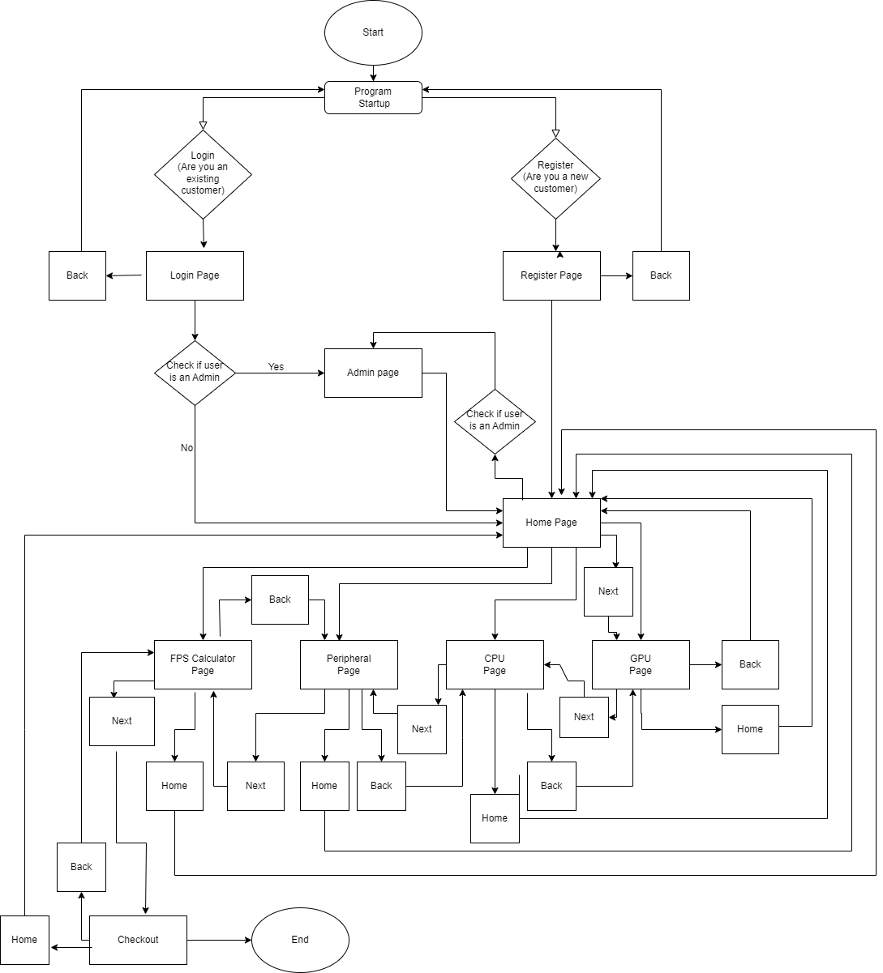

# **GUI Design**

## Tab Sheet 1 (Register for a new User):

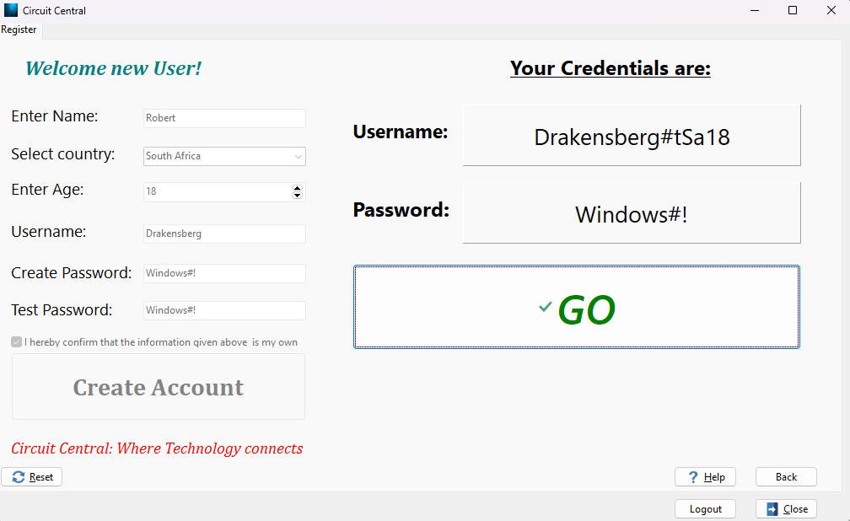

## INPUT:

| **Tabsheet 1 (tsRegister , Caption:’Register’)** | | | | |
| --- | --- | --- | --- | --- |
| **Variable name** | **Data type** | **Format (size, M/F for gender, yyyy/mm/dd)** | **Object Name** | **Local/Global variable** |
| sRegisterName | -String | Name stored as a string. String with at least 2 characters | edtRegisterName | Local |
| cNameLetter | Char | Store the letter of the name entered as chars.  The letters should not be equal to an empty space. | edtRegisterName | Local |
| iCountry- | integer | Select Country, store the value as an integer | cmbCountry | Local |
| iAge | Integer | Select or enter age and store the value as an integer. The minimum age is 18 and the maximum is 10, | sedAge | Local |
|  |  |  |  |  |
| // Below ↓ |  |  |  |  |
| sUsernameCreate | -string | Create the username and store in a string. Should be between 5 and 10 characters long | edtUsernameCreate | Local |
| sPasswordCreate | string | Enter the password that you want to use and store in a string. String should be between 5 and 10 characters in length. | edtPasswordCreate | Global |
| sPasswordCheck | string | Re-enter the password that you want to use and store in a string. | edtPasswordConfirm | Local |
| bInfoChecked | Boolean | Check or uncheck the checkbox. | chkConfirmDetails | Local |

## OUTPUT:

| **Tabsheet 1 (tsRegister , Caption:’Register’)** | | |
| --- | --- | --- |
| **Output** | **Format (Type, size)** | **Component** |
| Username | Username: <Username> | Panel |
| Password | Password: <Password> | Panel |

## 

## Tab Sheet 2 (Buy GPU’s):

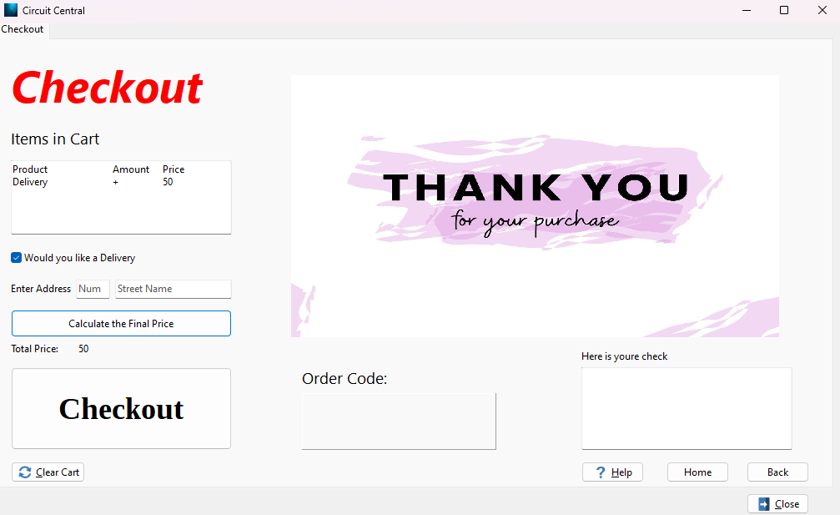

## INPUT:

| **Tabsheet 2 (tsCheckoout caption:’Checkout’)** | | | | |
| --- | --- | --- | --- | --- |
| **Variable name** | **Data type** | **Format (size, M/F for gender, yyyy/mm/dd)** | **Object Name** | **Local/Global variable** |
| bDelevery | Boolean | Select or unselect the checkbox to add funds and delivery to your order or remove it . | chkDelivery | Local |
| sStreetName | String | Enter your Street Name and store as a string. | edtStreetName | Local |
| edtRegisterName | edtRegisterName | edtRegisterName | edtRegisterName | edtRegisterName |
| sOrderCode | String | Generate random numbers and using in and the order Boolean create Order Number for the Customers order | btnCheckout | Local |

## 

## OUTPUT:

| **Tabsheet 2 (tsCheckoout caption:’Checkout’)** | | |
| --- | --- | --- |
| **Output** | **Format (Type, size)** | **Component** |
| Total Price | Total Price:<Total Price as a currency> | label |
| Order Code | Order code:<Order Code> | Panel |
| Cheque | Cheque:  <Username>  <Order Details>  <Total Price>  <Order Code> | Rich edit |
| Cart | Cart:  <Items in cart>  <Items in cart>  <Items in cart>  {Continue as cart expands} | Rich edit |

# 

# **IPO – Software Design Tool**

## INPUT VALIDATION: For screen One – Register

| **Input** | **Validation technique and description** | **Associated error message** |
| --- | --- | --- |
| Name  -Edit | I will test that there is a name inserted in the Edit | ‘Please Enter your name’ |
| Name  -Edit | I will test that the name entered is not just two empty spaces by comparing it as a char to a empty char | ‘Please enter Your name without spaces’ |
| Name  -Edit | I will test that the name entered in the edit is 2 characters or longer | ‘Please enter a name with two or more letters’ |
| Country  -Combo box | I will test that a country has been selected in the combo box | ‘Please select a country from the list provided’ |
| Age  -Spin edit | I will test that the user is older than 18 years old | ‘You must be at least 18 years old to create an account’ |
| Age  -Spin edit | I will test that the user is younger than 100 years old | ‘You must be younger than 100 years to create an account , please ask a family member for assistance’ |
| Username  -Edit | I will test that there is an username entered in the edit | ‘Please create an username’ |
| Username  -Edit | I will test that the username entered is equal or longer that 5 characters | ‘Username to short , must be at least 5 characters’ |
| Username  -Edit | I will test that the Username entered is equal or shorter than 10 characters | ‘Username to long , must me shorter than 10 characters’ |
| Username  -Edit | I will test that the username entered is only on word | ‘Username can only me one word’ |
| Password  edit | I will test that a password has been entered in the edit | ‘Please enter a Password’ |
| Password  Edit | I will test that the password contains at least 5 characters | ‘Password must contain at least 5 characters’ |
| Password  Edit | I will test that the password is no longer that 10 characters | ‘Password should be shorter than 10 characters’ |
| Password Test  Edit | I will test that a password has been entered in the edit | ‘Please enter the password again to make sure you know it’ |
|  |  |  |

## 

## PROCESSING:

|  |  |
| --- | --- |
| **What processing will be done** | **Algorithms, formulas, etc.** |
| **List:** | **Algorithms:** |
| 1Login :  Determine if the user is an admin or a customer or if the user does not exist when the login button is clicked | sUsername = input from user (edit)  sPassword = input from user(Edit)  iTries = 0  sCredentials = sUsername + sPassword  if sCredentials = sCredentialsAdmin  Show admin page  Set to admin page  Show all user Pages  Else  If sCredentials = sCredentialsPresetUserOne  Set to home Page  Make all other user pages available  Else  If If sCredentials = sCredentialsPresetUserCreate  Set to home Page  Make all other user pages available  {Else  iTries + 1  if iTries > 1  button to Register = visible  Show a message: ‘No account? Register Today’  Else  Show error message: ‘Please Check Credentials’} |
| 2Register:  Create a new account for the user and display there login details | sNameRegister = input from user(edit) – Name of User  sCountry = input from user (Country of user)  iAge = input from user(Spin edit)  sUsernameCreate = input from user (edit)–User Choose UserName  sPasswordCreate = input from user(edit)- User Choose Password  sPasswordTest = input from user(edit)- User re-enters password  cNamelastLetter = last letter of sNameRegister  cCountryFirstLetter = first letter of sCountry  cCountryLastLetter = last letter of sCountry  sUsernameTag = cNamelastLetter + cCountryFirstLetter + cCountryLastLetter + iAge  sRegisterUsername = sRegisterOwnUser + # + sUsernameTag  Show Username  Show Password  Show GO button |
|  |  |